Project Plan

SE Group 12

Nicolas Slack

Hayden Tucker

George Thomas

George Youssef

Han Yao

# Plan outline

Our project is planned to take 7 weeks, following this structure:

## Section 1 – Requirements Document

The first week of the project will be dedicated to elicitating a requirements document from the user specification provided to us. We will undertake this task as a whole team, and estimate this task to take one week.

This section falls into the critical project path.

## Section 2.a – Modelling Document

The second week of the project will be dedicated to creating modelling documentation from our requirements document. This will include high level domain diagrams, and low level class diagrams. Nick will undertake this task, and anticipates this task to take one week.

This section falls into the critical project path.

## Section 2.b – Ant Brain Creation

At the second week of the project, George will splinter off from the main effort to begin programming the ant brain for our team. George estimates this task will take two weeks to complete. The ant brain should not be required until the 5th week of the project, and as such he has a slack time of two weeks.

This section does not fall into the critical project path.

## Section 3.a – UI Creation

Starting on the third week of the project, Nick will separate off from the main effort to begin work on the User Interface for the code base. Nick estimates this will take one week to create. The User Interface is not required until the 5th week of the project, and as such he has two weeks of slack time.

This section does not fall into the critical project path.

## Section 3.b – Implementation Phase 1

The third week of the project sees the Coding team (George Thomas and Hayden) begin work on the main code base of the project, using the modelling document previously created. They estimate that the first implementation round will take one week of work.

This section falls into the critical project path.

## Section 4 – Testing Phase 1

The fourth week of the project will consist of the coding team conducting unit tests upon the previously created code base. This will also include java documentation of all currently existing code. The code team estimates that this process will take one week.

This section falls into the critical project path.

## Section 5 – Implementation Phase 2

The fifth week of the project will involve the entire team, as the coding team will begin implementing the UI created by Nick, and the ant brain created by George. All systems will be fully integrated together to prepare the software for systems testing. The team estimates this task set will take one week to complete.

This section falls into the critical project path.

## Section 6 – Testing Phase 2

The sixth week of the project will be the coding team conducting systems level testing on the fully integrated software that was constructed last week. At this point, Nick and George will begin preparations for final documentation. The code team thinks this task will take one week.

This section falls into the critical project path.

## Section 7 – Final Documentation

The seventh and final week of the project will see the whole team come together to finish off any outstanding documentation, review current documentation, and perform peer review mark assignment. The team estimates that this set of tasks should take no more than one week to finish.

This section falls into the critical project path.

# PERT Chart

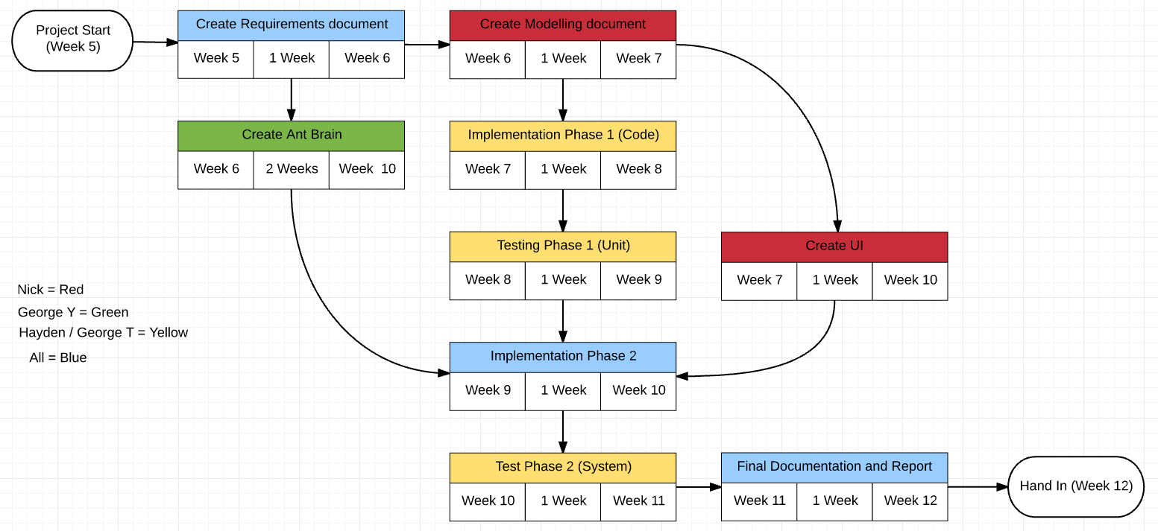Given below is the team’s *PERT* chart for the project

The critical path consists of:

1. Create requirements document
2. Create Modelling document
3. Implementation phase 1
4. Testing phase 1
5. Implementation phase 2
6. Testing phase 2
7. Final documentation and report

The project should take a maximum of 7 weeks to complete.